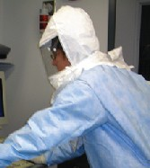
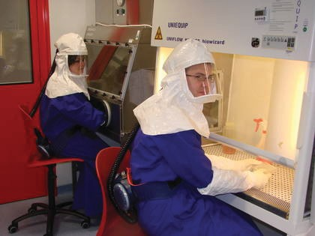
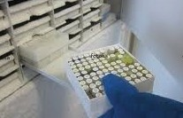
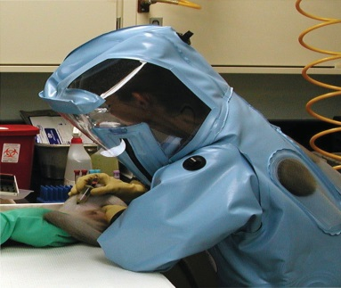

Occupational Health Program Template

(January 2017)

Centers for Disease Control and Prevention (CDC)
Division of Select Agents and Toxins (DSAT)
Animal and Plant Health Inspection Service (APHIS) Agriculture Select Agent Services (AgSAS)

Instructions for Using Occupational Health Program Template

The purpose of this document is to facilitate the creation of an occupational health program that meets section 12 of Select Agent Regulations 7 CFR Part 331, 9 CFR Part 121, and 42 CFR Part 73. This document template is made purposely customizable to fit the specific needs of the entity. Please note that this specific Occupational Health Program Template is provided as a guide and not required by FSAP to be used by the entity.

Review and Approval

The Occupational Health Program for this facility has been prepared with the intent of establishing and maintaining compliance with the Public Health Security and Bioterrorism Preparedness and Response Act of 2002 and 7 C.F.R. Part 331, 9 C.F.R. Part 121, and 42 C.F.R. Part 73. As required by the select agent regulations, this plan must be reviewed annually and updated, as needed. Lastly, the efficacy of this plan must be tested and evaluated with drills or exercises on an annual basis.

___________________________________________ __________________
Signature of Responsible Official Review Date

___________________________________________
Print Name

Occupational Health Program Template
Section 12(d) states that “the biosafety plan must include an occupational health program for individuals with access to Tier 1 select agents and toxins, and those individuals must be enrolled in the occupational health program.” See the Occupational Health Program guidance for more detailed information.
Additionally, entities registered for HPAI, SARS-CoV, and 1918 influenza virus should develop an occupational health program. See the Biosafety Guidance for more information.
Instructions: Describe in detail (or reference plans or SOPs that address the requirement) provisions for the following, based on an entity-specific risk assessment of all select agents and toxins that the entity is registered for, even if the entity does not currently possess a select agent or toxin on the list.
List all select agents and toxins registered with the entity, including modifications.

BSAT Precautions and Preventative Measures
List the precautions and preventative measures that will be taken when working with the select agents or toxins that the entity is registered for, including respiratory protection policies, other PPE policies, vaccinations (if available), and visitor policies.

If applicable: Describe or refer to OHP elements for working with Tier 1 select agents and toxins. See Section VII of the BMBL for more detailed information.

Medical Assessment and Surveillance
Ensure that a competent medical authority evaluates the following information for each individual prior to access to select agents or toxins:
- Previous and ongoing medical problems
- Current medications that may impact the individual’s ability to work with select agents or toxins
- Allergies
- Prior immunizations
- Necessary medical services to permit the individual to safely assume the duties of the position
Describe or refer to the procedure for periodic medical evaluations, including the point of contact:

Describe or refer to the procedure for emergency medical evaluations, including the point of contact:

Post Exposure Management
If applicable, describe or refer to the immediate/first aid actions to be taken in the event of an exposure incident.

Describe or refer to the procedure for post-exposure medical evaluations:

Describe or refer to procedures for providing post-exposure care and support for workers exposed to select agents or toxins for which effective pre- or post-exposure prophylactic measures exist.

If applicable: Describe or refer to procedures for providing post-exposure care and support for workers exposed to select agents or toxins for which effective pre- or post-exposure prophylactic measures have not been identified.

Describe or refer to procedures for when an employee reports symptoms that may have resulted from unrecognized exposure event. Note: An example may be to distribute medical alert cards to workers with access to select agent and toxins to validate the possibility of exposure quickly.

Hazard Communication
Describe the procedures for providing the following information to personnel with access to Tier 1 BSAT, HPAI, SARS-CoV, 1918 influenza virus, and products of restricted experiments (ex: antibiotic resistant strains):
- Risks and health hazards associated with the Tier 1 BSAT being used.
- Possible signs and symptoms of the diseases associated with the BSAT with which they work or share space with.
- Available pre- and post-exposure resources for treatment (including information on any available vaccine or prophylaxis options).
- Point of contact and what to do in an emergency.
- How to report and document all potential occupational exposures.

Reporting and Analyzing Occupational Exposure
Describe procedures for reporting all potential occupational exposures to identify contributing factors and corrective actions to be taken to mitigate the risk of recurrence.

Records Management and Retention
Describe procedure for collecting, safeguarding, and maintaining all personnel occupational health related documents and records for at least 3 years.

Modifications and Special Circumstances
Please describe any other policies of procedures relevant to your OHP that has not been covered by this form.

